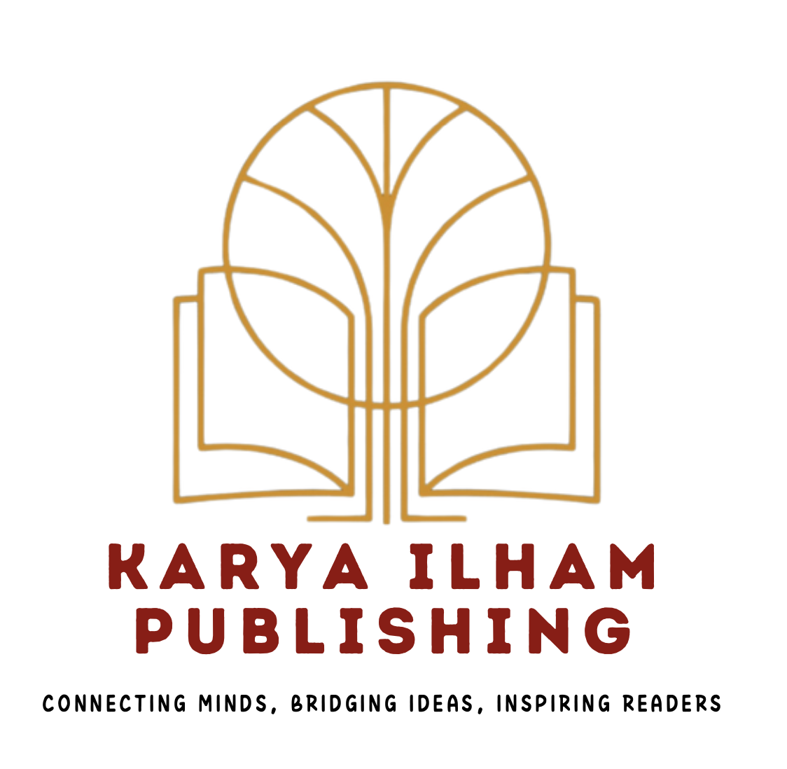 |  | Journal of Advanced Research in Social and Behavioural Sciences |  | 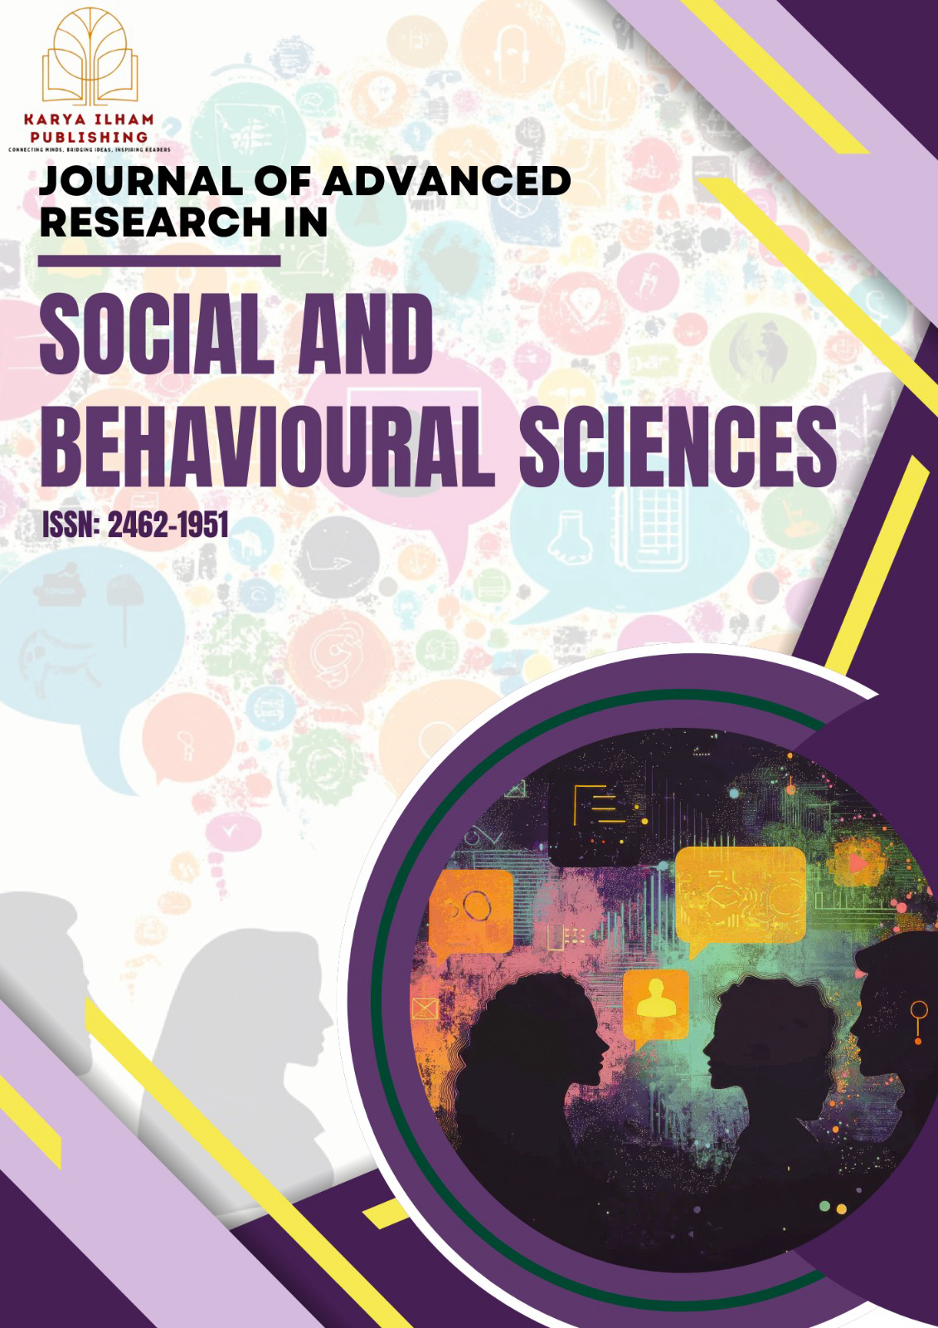
Journal homepage:
https://karyailham.com.my/index.php/jarsbs/index
ISSN: 2462-1951
“From Farm To Table” : The Agro-Business Module For Students with Special Educational Needs

Mohamad Aniq Aieman Junaidi¹, Rafeizah Mohd Zulkifli^{1,*} ,Mohd Azlan Mohammad Hussain¹, Zon Fazlila Mohd Ahir¹

¹ | Faculty of Technical and Vocational Education, Sultan Idris Education University, 35900 Tanjung Malim, Perak, Malaysia
ARTICLE INFO |  |  | ABSTRACT
Article history:  Received 27 March 2026  Received in revised form 21 May 2026  Accepted 10 June 2026  Available online 7 July 2026 |  |  | This study aims to identify the elements required for the development of the Agro-Business Module “From Farm to Table” and validate the Agro-Business Module “From Farm to Table” based on hydroponic crop cultivation to support teacher’s instruction for Students with Special Educational Needs (SEN). The development of this module was undertaken to meet the needs of practical learning, systematic, and entrepreneurship-oriented vocational skills teaching in line with the basic agricultural Vocational Skills Curriculum Document (DKKV). The module adopts a hands-on approach covering the entire “From Farm to Table” process, from seed germination and hydroponic cultivation to harvesting, processing, and marketing. The research design adopted a module development study approach involving three main phases: needs analysis, module design and development, and evaluation. Data for the need analysis phase were collected through interviews with two lecturers from the Faculty of Technical and Vocational Education and three special education teachers with experience in agriculture and SEN instruction. Findings from the needs analysis indicate that hydroponic cultivation activities are highly suitable for the SEN context due to their short cultivation period, ease of management, safety, and ability to enhance students’ understanding through hands-on learning. Expert validation results revealed that the developed module achieved its objectives, was appropriate, and presented information clearly for special education teaching. The module was also found to be effective in assisting teachers to plan and implement instruction in a more structured manner, while increasing active engagement among SEN students in learning activities. In conclusion, the Agro-Business Module “From Farm to Table” has the potential to serve as a practical and relevant instructional support material for special education teachers and to contribute holistically to the development of vocational and entrepreneurial skills among SEN students.
Keywords:

Special Needs Students (SEN), Agro-Business Module “From Farm to Table”, Project-Based Learning, Hydroponic Crop Cultivation, From Farm to Table, teacher’s instruction for Students with Special Educational Needs (SEN)

1. Research Background

Students with Special Educational Needs (SEN) are a group of learners who have unique cognitive, physical, social, or emotional needs that require appropriate teaching and learning approaches. According to Mohd Kamil et al., [15], a literature review indicates that students with special needs require the mastery of life skills and independent living skills to support their participation in inclusive education and their daily lives. In addition, learning approaches that emphasize direct experience through practical activities have been shown to support the development of interpersonal skills and social acceptance among students with special educational needs, demonstrating that experiential-based methods not only enhance conceptual understanding but also promote students’ social well-being in inclusive learning environments [18].
However, the reality in schools indicates that teaching approaches for Students with Special Educational Needs (SEN) remain largely academically oriented and teacher-centred, despite the recommendation of various pedagogical approaches that are more contextual and student-centred. Studies have found that the implementation of practical, contextual, and student-centred teaching strategies in special education and inclusive classrooms is still limited, resulting in fewer opportunities for SEN students to engage in enjoyable and meaningful learning experiences [14]. This situation causes SEN students to experience difficulties in understanding the concepts being taught, reduced motivation to learn, and a failure to develop confidence and skills that can be applied in real-life situations. Research shows that students with special educational needs often experience low self-confidence and intrinsic motivation, particularly when faced with complex learning tasks that are insufficiently supported by appropriate pedagogical approaches [12]. In addition, literature reviews have reported that the academic self-concept of SEN students in inclusive education settings remains at a low level, which is closely associated with their engagement, achievement, and ability to apply learning in authentic contexts [22]. Furthermore, some special education teachers may have limited exposure to innovative teaching methods that are aligned with students’ needs.
Therefore, modern agricultural fields such as hydroponics offer significant potential as a skill-based learning approach that can be adapted to the capabilities of SEN students. This method allows students to be directly involved in practical activities, enhances conceptual understanding, and builds skills through real experiences [3]. Hydroponics is a method of growing plants without soil using nutrient solutions, which can be implemented on a small scale, is easy to maintain, and produces results in a short period. This method not only allows students to be directly involved in the planting process but also provides opportunities for them to learn through observation, practical exercises, and real-life experiences. Literature studies show that an experiential learning approach, where students are actively involved in practical activities, can enhance conceptual understanding and foster more meaningful learning when real-world experiences are integrated into teaching and learning [38].
However, there is still a lack of learning modules specifically developed to integrate hydroponic activities in the context of SEN education. According to Choo Siang in the PPKI Management Report of SMK Tabuan Jaya (2022–2023), the school implemented a hydroponics project as part of manipulative skills training for SEN students. These activities aim to develop the sensory and motor skills of SEN students and prepare them for career transitions. However, there is no reference to a formal learning module specifically designed for SEN learners.
In addition, Existing modules are usually general, did not consider students’ cognitive, psychomotor, social abilities, and lack the integration of holistic learning concepts. Beside, the use of teaching aids that are unsuitable for the needs and abilities of students with special educational needs makes this issue more serious and challenging to address. Furthermore, the lack of systematic and appropriate modules for the widespread implementation of hydroponics is also a crucial issue, which explains why this Agro-Business module needs to be developed to support teachers’ instruction for Students with Special Educational Needs (SEN).
Therefore, this study aims to address these issues by developing the “From Farm to Table” Agro-Business Module focusing on hydroponic cultivation for SEN students. The module provides an engaging and effective teaching platform for SEN teachers, supports students’ self-confidence, social skills, and practical abilities, and promotes environmental sustainability and healthy lifestyles through hydroponic farming and the consumption of fresh, nutritious produce.
The “From Farm to Table” approach have a unique approve which provide complete guidance for SEN teachers from planting, maintenance, and harvesting, food preparation follow by sales and marketing. This concept not only empowers farming skills but also enhances students’ understanding of the importance of healthy eating and food safety and also can apply entrepreneurship knowledge within SEN students.

2. Research Objectives

The following are the research objectives for the development of this module :
i. Identifying the elements required for the development of the Agro-Business Module “From Farm to Table” : Hydroponic Crop Cultivation for teacher’s instruction of Students with Special Educational Needs (SEN)
ii. Developing the Agro-Business Module “From Farm to Table” : Hydroponic Crop Cultivation for teacher’s instruction of Students with Special Educational Needs (SEN)
iii. Determining the validity of the Agro-Business Module “From Farm to Table” : Hydroponic Crop Cultivation for teacher’s instruction of Students with Special Educational Needs (SEN) based on expert opinions

3. Methodology

This study applied a developmental research approach, focusing on the production and evaluation of the Agro-Business Module “From Farm to Table” for SEN teacher instruction. Developmental research was chosen because it is suitable for examining the design, development, and evaluation of instructional materials that are specific to a particular context or target group [27]. This study was conducted using the ADDIE Model (Analysis, Design, Development, Implementation, and Evaluation), a widely used instructional design model in the creation of teaching materials across various contexts [21].
This need analysis and validation phase in this study employed a qualitative method that emphasizes exploration and in-depth understanding of the requirements, effectiveness and appropriateness of the Agro-Business Module “From Farm to Table” for SEN teacher instruction. Data were collected through interviews with expert panels, comprising special education teachers and lecturers which have 5 years and above experience in urban agriculture at Faculty of Technical and Vocational Education, UPSI. This method was selected because it allows participants to share richer and more detailed experiences, insights, and suggestions regarding the implementation of the hydroponics module [11]. The use of a qualitative design also aligns with Richey and Klein’s [27] recommendation that qualitative approaches are advantageous in the development and evaluation of instructional materials, as they can reveal the meaning, context, and practical value of materials from the users’ perspective.
The data obtained from the interviews were analyzed thematically to identify patterns, themes, and specific needs relevant to hydroponic instruction for SEN students. This analysis enables the researchers to gain a clearer understanding of critical aspects that must be considered in the development and implementation of the module to meet the needs of teachers and SEN students more effectively [8].
Overall, the design of this study places full emphasis on exploring the experiences and perceptions of the participants to ensure that the Agro-Business Module “From Farm to Table” is designed, developed, and tailored to the actual needs of teachers and SEN students in terms of implementation, effectiveness, and instructional suitability.

Research Procedure Based on the ADDIE Model:

i. Analysis Phase

A needs analysis was conducted to identify the actual requirements and preferences of special education teachers (SEN) and lecturers from the Faculty of Technical and Vocational Education (FTV) in the development of the Agro-Business Module “From Farm to Table” based on hydroponic cultivation. The process began with semi-structured interviews with both groups of respondents to obtain in-depth information regarding their experiences, challenges, and needs in implementing practical and agricultural instruction for SEN students. Special education teachers were interviewed to obtain a realistic overview on how to teach in the classroom by special education teachers. Therefore, the responses obtained will be analyzed to help identify key elements for the development of the “From Farm to Table” Agro-Business Module that can support teachers’ instruction in the classroom. In addition, a lecturer specializing in urban agriculture from Universiti Pendidikan Sultan Idris was also interviewed, with the role of providing an analysis of the suitability of the activities and hydroponic systems to be used by Students with Special Educational Needs, in order to prevent any undesirable risks.
The interview data were transcribed and thematically analyzed to identify key themes, including limitations in learning resources, the need for visual and practical teaching aids, basic hydroponic farming knowledge, and learning strategies suitable for SEN students. Understanding these needs ensures the module is relevant and effective in supporting SEN teachers in helping students comprehensively master modern agricultural concepts and skills.

ii. Design Phase

The design and content of the “From Farm to Table” Agro-Business Module based on hydroponic cultivation were systematically planned according to constructivist learning principles to ensure suitability for both teachers and Students with Special Educational Needs (SEN). The module emphasizes student-centered learning, real-life experiences, and active knowledge construction among MBPK through structured hydroponic activities such as seed germination, crop maintenance, harvesting, and product marketing. These activities allow MBPK to explore, experiment, and understand agricultural and entrepreneurial concepts through direct experience. Teachers assume the role of facilitators by guiding students through questioning, discussion, and reflection rather than one-way instruction, enabling students to connect new knowledge with prior experiences and develop more meaningful and contextual understanding. Additionally, collaborative and problem-solving activities embedded in the module promote social interaction and active learning, aligning with constructivist principles that view learning as most effective when students actively construct knowledge through real-world experiences. Accordingly, these principles underpin the development of the Agro-Business Module to ensure engaging and effective teaching and learning for SEN students. The module includes a teacher’s guide and daily lesson plans, foundational hydroponics theory, step-by-step illustrated practical procedures, activity sheets, formative assessment instruments, and creativity and entrepreneurship elements such as producing value-added products from harvested crops.
Moreover, the module emphasizes student-centered learning through clear language, supportive visuals, and progressive hands-on activities, enabling SEN students to conduct hydroponic projects confidently and independently. Its flexible and inclusive design allows teachers to adapt learning according to students’ needs and abilities, creating practical and meaningful experiences. The module was designed using Canva in B5 size.

iii. Development Phase

The development of the Agro-Business Module “From Farm to Table”, based on hydroponic cultivation, was carried out in a planned and systematic manner using Constructivist Theory. At this stage, findings from the analysis phase were used as the foundation for designing a module that is relevant and addresses the actual needs of SEN teachers.
The module’s content was developed according to constructivist learning principles, emphasizing active learning, concrete experiences, and adaptation to students’ levels. Agro-Business modules include a detailed teacher’s guide, daily lesson plans, fundamental hydroponics theory, step-by-step illustrated practical procedures, activity sheets, and formative assessment instruments. All content is designed to be easily understood and implemented progressively according to students’ abilities. In addition, the module’s development emphasizes the use of clear visuals and concise language, while incorporating entrepreneurship elements, such as producing products from harvested crops. Hands-on approaches and project-based learning are used to help SEN students progressively develop practical skills under teacher guidance.
Overall, as shown in Figure 1, the module aims to provide teachers with a comprehensive, flexible, and inclusive teaching resource that facilitates the teaching process while enhancing SEN students’ ability to understand and apply modern agricultural concepts through hydroponic cultivation.

(a) Determination of Module Objectives

The determination of module objectives is a crucial initial phase in the module development process, as these objectives form the foundation for content design, instructional strategies, and assessment methods. Accordingly, the objectives were clearly defined, specific, measurable, and aligned with the cognitive, physical, and social abilities of SEN students to ensure feasible and effective learning.
These objectives cover both theoretical knowledge, such as identifying types of hydroponic crops and understanding basic hydroponic concepts, and practical skills, including the ability to carry out the cultivation process progressively from seed germination to harvesting. In addition, the module includes objectives related to basic entrepreneurial skills, providing SEN students with early exposure to the world of work and foundational agricultural practices.
Each objective developed is directly aligned with the (Dokumen Kurikulum Kemahiran Vokasional, DKKV) syllabus and integrates cross-curricular elements such as communication skills, moral values, and entrepreneurship to ensure a holistic and integrated learning experience. Through well-planned objective setting, the module provides clear instructional direction, supports the achievement of intended learning outcomes, and guides teachers in delivering instruction in a more structured, accessible, and focused manner that addresses the specific needs of SEN students in basic agricultural education.

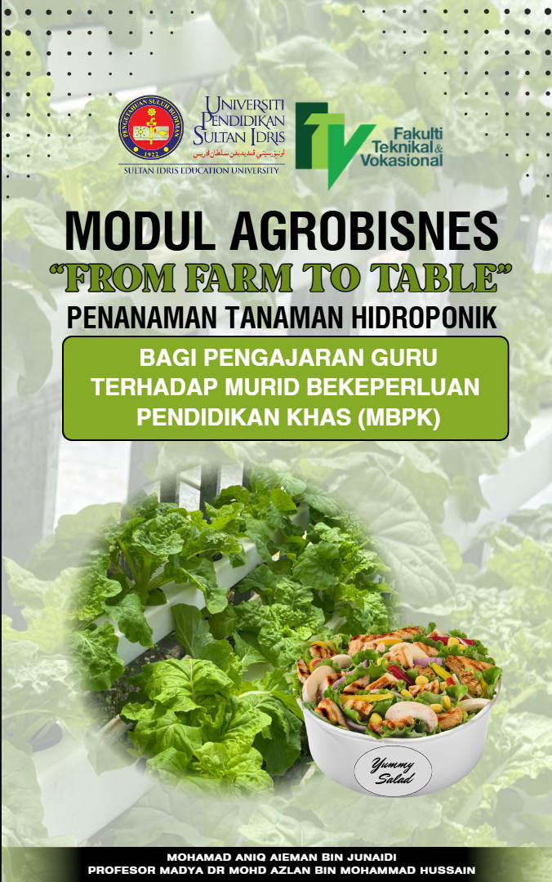

Fig. 1. Front page of Agro-Business Module

(b) Selection of Module Content and Structure

The selection of the module content and structure in this study was systematically and progressively planned to ensure that learning occurs in an organized, continuous, and learner-appropriate manner. Accordingly, the module is divided into three interrelated main chapters, structured based on the principle of progression from foundational knowledge to application (see Figure 2)..
Chapter 1: Introduction to Hydroponics aims to provide students with a conceptual understanding of the definition, concepts, importance, and types of hydroponic systems as foundational knowledge before advancing to practical components.
Next, Chapter 2: Hydroponic Cultivation Procedures emphasizes detailed implementation steps, including the preparation of materials, planting techniques, crop maintenance, pest control, and the harvesting of salad crops. This chapter is designed to develop students’ practical skills and confidence through hands-on, experiential learning.
Finally, Chapter 3: Entrepreneurial Practices is included to connect technical knowledge and skills with economic value-added elements. In this chapter, students are introduced to basic entrepreneurship concepts such as production, marketing, and management of harvested salad crops.
Overall, the module structure is developed progressively to ensure learning continuity, a balance between theory and practice, and support the achievement of comprehensive learning objectives. Accordingly, the module is organized into the following main chapters:

● Chapter 1 : Introduction to Hydroponics
● Chapter 2 : Hydroponic Cultivation Procedures
● Chapter 3 : Entrepreneurial Practices

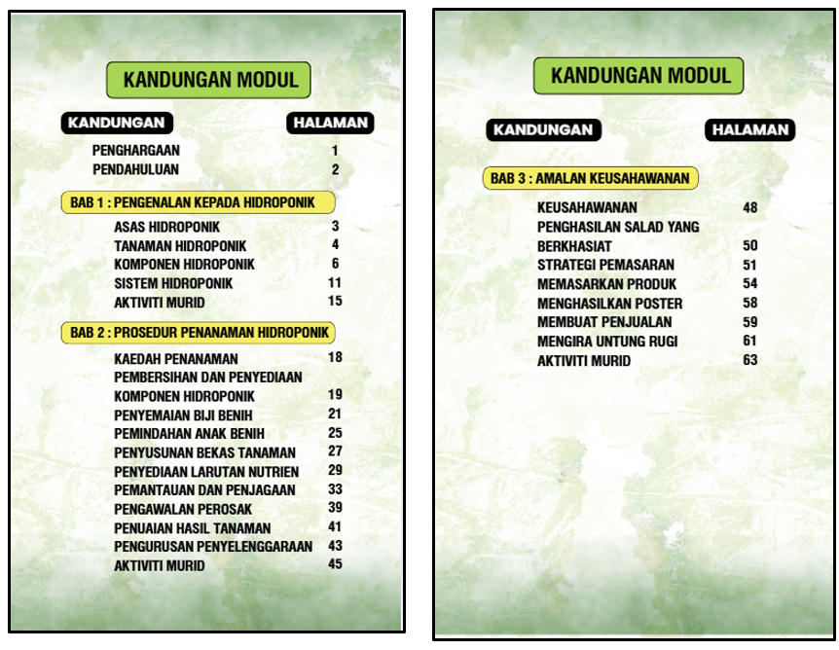
Fig. 2. Content part of Agro-Business Module

(c) Teaching Approaches and Methods

This module is designed with a strong emphasis on a student-centered approach to ensure that Students with Special Educational Needs (SEN) are actively engaged in the learning process rather than relying solely on teacher explanations. Its implementation incorporates various teaching strategies, including visual materials, teacher demonstrations, hands-on learning, and practical activities that enable students to learn through real-life experiences.
The use of visual elements such as images, pictorial charts, and step-by-step illustrations helps students with special educational needs (SEN) understand concepts more easily, as visual information presentation can break down complex learning processes into clear, structured, and easy-to-follow steps. Studies have shown that the use of illustrated instructions in instructional materials can enhance students’ understanding, as visuals function as cognitive supports that help learners comprehend the sequence of actions before performing them independently [13]. In addition, the systematic integration of visual elements into learning modules has been found to reduce cognitive load and improve students’ ability to process information effectively, thereby supporting students who require visual support, including those with special educational needs [5]. Therefore, direct demonstration as a teaching method provides a clear representation of how an activity is carried out before students perform it themselves.
In addition, the module provides instructions that are organized clearly, concisely, and sequentially to facilitate effective teaching and help SEN students follow each step without confusion. This step-by-step approach, as can be seen in Figure 3, allows students to understand each process in a structured manner and reduces cognitive load. The module’s activities also prioritize safety, ensuring that the materials and equipment used are appropriate and pose minimal risk to SEN students.
Furthermore, the module’s activities are engaging and interactive, enhancing motivation while supporting SEN students’ gross and fine psychomotor skills, such as hand–eye coordination and tool manipulation. Overall, the module fosters both academic learning and the development of motor skills and self-confidence.

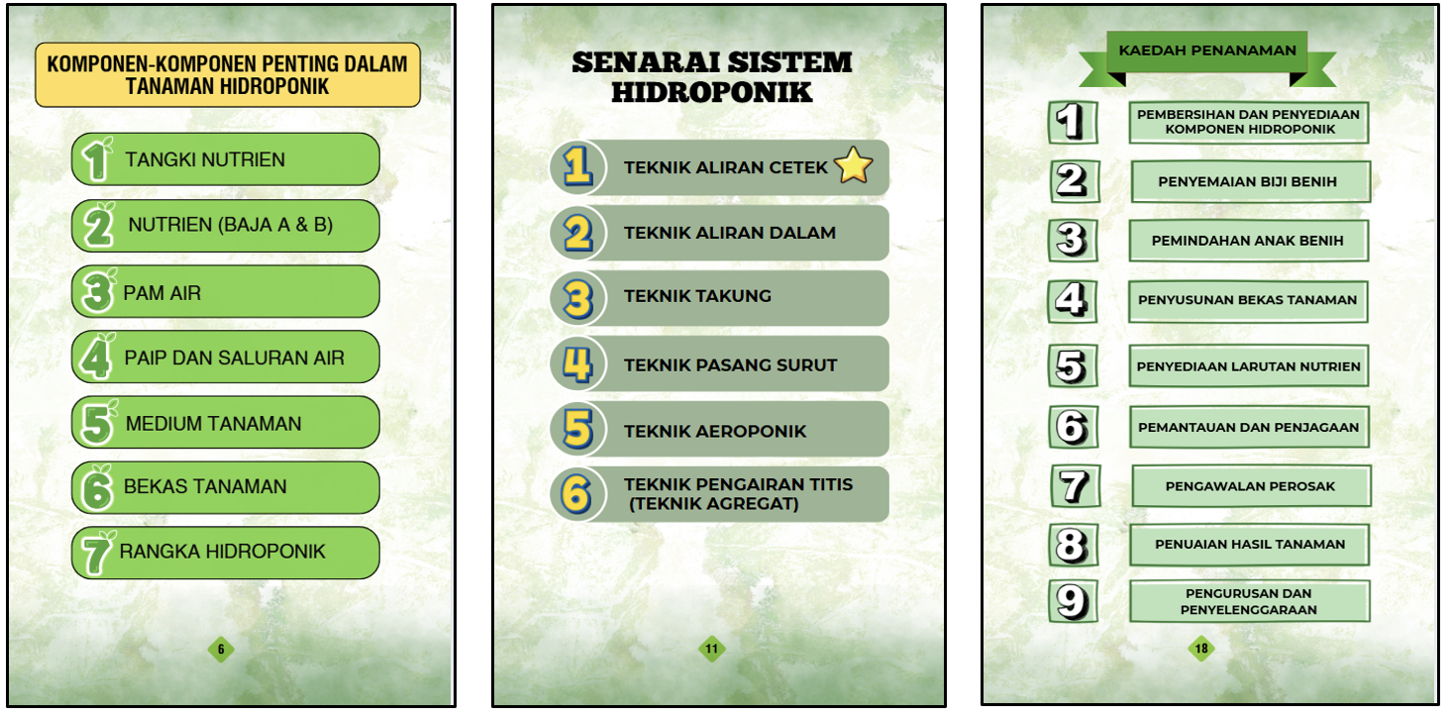
Fig. 3. Concise and easy to understand Agro-Business Module notes

(d) Evaluation and Continuous Assessment Elements

Assessment elements and continuous evaluation are integral to the module, enabling comprehensive monitoring of SEN students’ learning. Each chapter includes rubric-based instruments to assess conceptual understanding, practical skills, and social skills. Conceptual understanding is assessed through written activities, question-and-answer sessions, or observations of students’ comprehension of the concepts taught (see Figure 4). Practical skills are evaluated based on students’ ability to perform hands-on activities, such as setting up hydroponic systems and properly maintaining crops. In addition, SEN students’ social skills are also emphasized through observations of their cooperation, communication, and behavior during group activities.
This continuous assessment approach enables teachers to identify students’ levels of mastery progressively and to recognize their strengths and weaknesses in each chapter. Through systematic evaluation, teachers can adjust instructional strategies when students require additional support. This approach also ensures that students’ learning progress is monitored consistently, rather than being assessed only at the end of instruction. Overall, the continuous assessment elements incorporated in this module are not only intended to measure student achievement but also to support a more inclusive, flexible, and learner-centered learning process that focuses on the individual needs of SEN students.

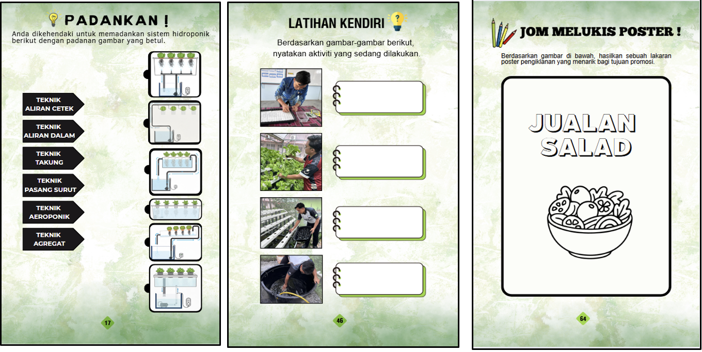
Fig. 4. Evaluation and continuous assessment tested for SEN students

(e) Integration of Entrepreneurship and Healthy Nutrition Elements

The integration of entrepreneurship and healthy nutrition elements in this module aims to provide holistic exposure for Students with Special Educational Needs (SEN) through meaningful and experiential learning. Figure 5 shows that the module incorporates practical activities such as preparing salads from hydroponically grown produce, alongside exposure to healthy eating concepts to enhance students’ awareness of the importance of a balanced diet.
In addition, basic entrepreneurial activities such as income generation, sales recording, and interaction with the school community help SEN students develop social, mathematical, and communication skills in practical, contextual ways.
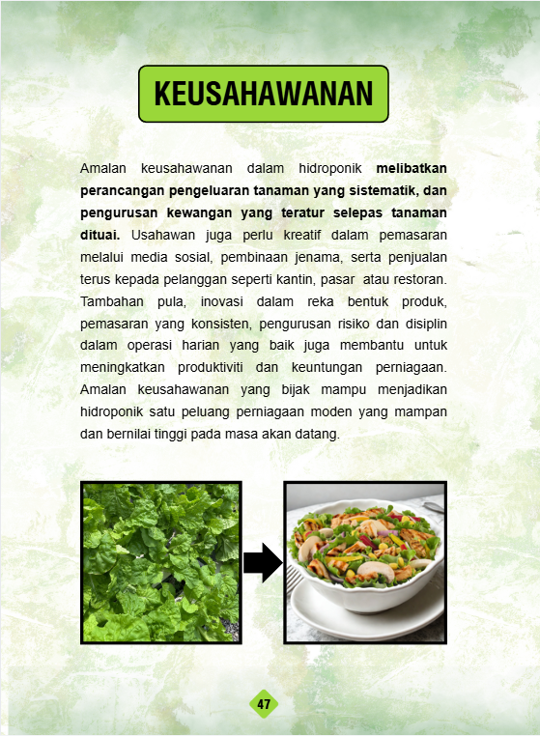

Fig. 5. Entrepreneurship elements applied

iv. Implementation Phase

The implementation of hydroponic cultivation in the Agro-Business Module “From Farm to Table” involves practical learning, where the researcher, along with a group of SEN students, personally carried out each stage of planting in a hands-on manner (see Figure 6). Activities began with preparing basic equipment, such as planting containers, growth media, and nutrient solutions, followed by sowing seeds and caring for seedlings until maturity.
In addition, the researcher observed and recorded plant growth continuously to evaluate the effectiveness of the hydroponic techniques used. Through this project-based learning approach, the researcher concluded that SEN students would have the opportunity to acquire practical skills in modern agriculture, while also developing responsibility and independence, thereby providing them with a more suitable and meaningful learning experience.
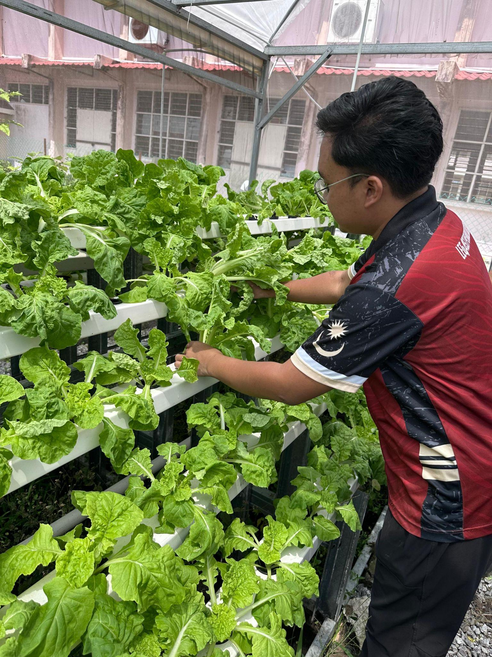

Fig. 6. Hydroponic projects implemented by the researcher

v. Evaluation Phase

The “From Farm to Table” Agro-Business Module was evaluated and validated by experts to ensure its content, design, and implementation are appropriate, high-quality, and aligned with SEN teaching objectives. Reviews and feedback were obtained from SEN teachers and lecturers specializing in hydroponics and instructional material development. Experts assessed the module’s language and visuals, technical hydroponic content, project-based learning effectiveness, and classroom relevance. Using qualitative interviews, feedback was recorded, transcribed, and analyzed to identify the improvement. Therefore, this expert evaluation and validation are crucial to ensure that the developed module is relevant, practical, and capable of making a significant impact on the teaching of SEN teachers and the learning of SEN students.

4. Results And Discussion

The discussion of the study findings examines the results of interviews with lecturers and special education teachers who evaluated the Agro-Business Module “From Farm to Table” from the perspective of the study objectives, namely identifying the required elements, developing the module, and determining its validity.

Summary of Objective 1 : Identifying the elements required for the development of the Agro-Business Module “From Farm to Table” : Hydroponic Crop Cultivation for SEN Teacher Instruction

First, the elements required in module development include a clear content structure, consistent learning objectives, and teaching and learning (T&L) steps that are easy to understand and appropriate to the abilities of Students with Special Educational Needs (SEN). In this study, the objective of identifying the elements of module development was achieved when the findings from the needs analysis interviews revealed that an effective module should have clear learning objectives aligned with the curriculum, relevant content, appropriate teaching strategies encompassing both theory and hands-on activities, as well as a student-centred approach [19]. The same study emphasised that inclusive learning design should consider individual needs through the adaptation of the learning process to help students achieve their full potential [19]. In addition, another study found that in the context of modern inclusive T&L, teachers should employ inclusive practices that encompass affective, behavioural, cognitive, competency, and awareness aspects to maximise the participation of students with diverse needs, including in online learning and through the use of educational technology as a support tool [7]. These inclusive practices include content adaptation, the use of multi-format instructional materials, and continuous assessment that enables teachers to formulate T&L strategies appropriate to students’ abilities.
Therefore, these elements are aligned with the principles of inclusive pedagogy, which emphasise content adaptation, flexible teaching strategies, appropriate teaching aids, and active student engagement in learning activities. This approach is crucial for special education as it maximises the learning experiences of every student regardless of their level of ability, while fulfilling the principles of inclusive education that require T&L strategies to be modified and adapted according to individual needs throughout the learning process [19].

Summary of Objective 2 : Developing the Agro-Business Module “From Farm to Table” : Hydroponic Crop Cultivation for SEN Teacher Instruction

Second, in module development, the research data found that the module needs to be developed systematically with step-by-step instructions, the use of supporting media such as images and diagrams, and the integration of entrepreneurial components as well as practical projects such as the sale of hydroponic salad produce. This process reflects an active learning approach and project-based learning (PBL), which can enhance the engagement of Students with Special Educational Needs (SEN) in teaching and learning (T&L) by providing real-world experiences, particularly in the context of agro-business and vocational skills [24]. In this study, the objective of developing the Agro-Business Module was achieved because module development is important in encouraging SEN teachers to carry out teaching activities in the classroom more easily and in a more structured manner, while also taking into account essential elements required to produce a high-quality module. A study on the development of interactive digital modules for SEN students showed that the use of structured and interactive digital modules can enhance students’ understanding, motivation, and confidence in vocational learning, while simultaneously assisting teachers in implementing T&L more effectively [37]. In addition, studies on the development of adaptive technology-based modules emphasise that learning modules tailored to the needs of SEN students can improve access, quality, and learning effectiveness by enabling the adaptation of content, methods, and the pace of T&L according to individual abilities [20].
Practical activities such as sowing, fertilising, and harvesting crops not only provide manipulative experiences but also develop a deeper conceptual understanding while fostering life skills and social skills [24]. The study respondents also emphasised the need to provide safety guidelines, assessment training, and enrichment materials such as demonstration videos as important strategies in supporting T&L and strengthening the usability of the module for teachers without an agricultural background.
These findings are also consistent with other studies showing that interactive, visual, and easily accessible learning materials can enhance students’ motivation, understanding, and confidence in vocational and practical T&L [23]. Overall, the integration of active learning approaches, PBL components, and interactive media has been proven to support students’ learning experiences holistically and to help overcome traditional challenges in teaching vocational skills to SEN students.

Summary of Objective 3 : Determining the validity of the Agro-Business Module “From Farm to Table” : Hydroponic Crop Cultivation for SEN Teacher Instruction based on expert opinions

Third, in the context of module validity based on the views of experts and special education teachers, the interview reports indicate that the module is considered pedagogically valid because it provides relevant, clear content and offers comprehensive guidance for the T&L of SEN teachers. Teachers’ understanding of the module improved after exposure to its content, particularly when the module detailed hydroponic procedures and linked them practically with entrepreneurial elements such as sales and cost calculation. This shows that the third objective of the study was achieved, as teachers provided positive feedback on the content and structure of the guidance [35].
Furthermore, the module is not merely theory-based but can be integrated into actual teaching practices, emphasising holistic learning and systematic project planning. This aligns with the principles of Universal Design for Learning (UDL), which emphasise multiple means of engagement, representation, and expression to help SEN students explore content through different approaches [30]. This approach strengthens the relationship between responsive teaching strategies and the effectiveness of T&L in inclusive special education.
In addition, systematic studies indicate that the use of digital technology as a support for inclusive pedagogy can enhance the learning experiences of students with special needs through visual, interactive, and adaptive resources, while also assisting teachers in planning and assessing learning effectively [34]. Such technology integration is an essential element in ensuring that learning modules are not only easy to understand but also dynamic and engaging for various learning styles.
Moreover, research on inclusive pedagogy in Malaysia shows that the perceptions, practices, and implementation of inclusive education continue to evolve, where teachers and stakeholders recognise the importance of pedagogical systems that support the learning of all students fairly and equitably in an inclusive learning environment [10]. This provides additional support that the pedagogical validity of the developed module aligns with broader inclusive education practices at the national level.
Overall, the study’s objectives were achieved, with the Agro-Business Module effectively addressing SEN teachers’ needs while reinforcing inclusive pedagogy and UDL. Its integration of visuals, practical activities, continuous assessment, and project planning supports effective and meaningful teaching for SEN students.

Acknowledgement
This paper was part of a research project entitled “A Quality Standard in Vocational Education for Students with Special Needs;” funded by the University Pendidikan Sultan Idris Research Grant. (2020-11-15 to 2022-11-14).

References

[1] Kamarulzaman, W., and A. A. Rahman. Halangan yang Ditempuh oleh Guru Aliran Perdana di Malaysia dalam Melaksanakan Program Pendidikan Inklusif. 2023.https://www.researchgate.net/publication/371285692_HALANGAN_YANG_DITEMPUHI_OLEH_GURU_ALIRAN_PERDANA_DI_MALAYSIA_DALAM_MELAKSANAKAN_PROGRAM_PENDIDIKAN_INKLUSIF
[2] Ahmad, Sani Bin, Ahmad Zakwan Bin Zaimani, Muhammad Zahin Bin Hakim, Diyana Zulaika Binti Abdul Ghani, and Nina Diana Binti Nawi. "Mengatasi Masalah Kekurangan Bahan Pengajaran dan Pembelajaran Pendidikan Khas melalui Laman Web (Portal)." (2023). https://www.researchgate.net/profile/Sani-Ahmad-5/publication/367188215_Mengatasi_Masalah_Kekurangan_Bahan_Pengajaran_dan_Pembelajaran_Pendidikan_Khas_melalui_laman_web_Portal/links/63c5f34fe922c50e999df496/Mengatasi-Masalah-Kekurangan-Bahan-Pengajaran-dan-Pembelajaran-Pendidikan-Khas-melalui-laman-web-Portal.pdf
[3] Almerino, J., and J. N. Peria. "Enhancing biology education through hydroponics: A practical approach in high school classes." The Quest: Journal of Multidisciplinary Research and Development 3 (2024).https://doi.org/10.60008/thequest.v3i1.190
[4] Arifin, N. R. (2023). Pembangunan dan kebolehgunaan modul Urban Farming STEM untuk literasi STEM dalam kalangan murid sekolah menengah [Tesis Sarjana, Universiti Kebangsaan Malaysia]. https://ptsldigital.ukm.my/jspui/handle/123456789/563472
[5] Asilestari, Putri, Raffly Henjilito, and Vitri Angraini Hardi. "Enhancing Reading Comprehension through Visual Information: A Longitudinal Study in Higher Education." AL-ISHLAH: Jurnal Pendidikan 17, no. 2 (2025): 2415-2434. https://www.journal.staihubbulwathan.id/index.php/alishlah/article/download/7490/2890
[6] Azahari, Nur Hazwanie, Isa Hamzah, and Mohd Hanafi Mohd Yasin. "Tahap latihan dan kemahiran guru pendidikan khas menghadapi cabaran pelaksanaan mata pelajaran kemahiran vokasional spesifik (KVS) berdasarkan kurikulum standard sekolah menengah pendidikan khas (KSSMPK)." Jurnal penyelidikan TEMPAWAN 37 (2020): 24-34.https://tempawan.ipgkik.edu.my/wp-content/uploads/2021/01/ARTIKEL-3-TAHAP-LATIHAN-DAN-KEMAHIRAN-GURU-PENDIDIKAN-KHAS-MENGHADAPI-CABARAN-PELAKSANAAN-MATA-PELAJARAN-KEMAHIRAN-VOKASIOANAL-SPESIFIK-2.pdf
[7] Bong, Way Kiat, and Kah Heng Chua. "Assessing Teachers’ Practices in Providing Inclusive Online Education: Development and Validation of an Instrument Based on Inclusive Practices among Teachers in Malaysia." Education Sciences 13, no. 9 (2023): 918.https://doi.org/10.3390/educsci13090918
[8] Braun, Virginia, and Victoria Clarke. "Thematic analysis: A practical guide." (2021): 1-100.https://www.researchgate.net/publication/382853995_Thematic_Analysis_A_Practical_Guide
[9] Choo S., (2023). Buku Laporan Pengurusan PPKI SMK Tabuan Jaya 2022-2023. https://fliphtml5.com/ptqsc/qjom/
[10] Sek, Chua Tuan, and Low Hui Min. "Inclusive education: Perception, practice and implementation within Malaysia." Best Practices in Disability-Inclusive Education 3, no. 1 (2024).https://doi.org/10.37134/bitara.vol17.sp.13.2024
[11] Creswell, J. W., & Creswell, J. D. (2019). Research Design: Qualitative, Quantitative, and Mixed Methods Approaches (5th ed.). SAGE Publications. https://spada.uns.ac.id/pluginfile.php/510378/mod_resource/content/1/creswell.pdfhttps://www.researchgate.net/publication/336223127_Research_Design_Qualitative_Quantitative_and_Mixed_Methods_Approaches_by_John_Creswell_and_J_David_Creswell
[12] Garbenis, Simas, and Irena Kaffemaniene. "Developing traits of self-confidence and intrinsic motivation in students with severe special educational needs in physical education lessons." Behavioral Sciences 15, no. 11 (2025): 1449. https://www.mdpi.com/2076-328X/15/11/1449
[13] Gurung, Regan AR, and Paige Herrboldt. "Picture this: Studying the effectiveness of illustrated instructions." Teaching of Psychology 52, no. 4 (2025): 397-402. https://doi.org/10.1177/00986283241255965
[14] Husin, Mohd Razimi, Aeidah Farhana Nor Rahmat, Afina Fashihah Rosle, Fairuz Syakirah Mohamad Hassan, Farah Shamimi Mat Nawi, Melisa Abraham Abiraham, Noorshaqilah Abd Rahman et al. "Strategi dan teknik pdpc bagi mengendalikan murid berkeperluan khas ketidakupayaan pendengaran dalam pendidikan inklusif." Journal of Humanities and Social Sciences 5, no. 2 (2023): 75-87. https://doi.org/10.36079/lamintang.jhass-0502.550
[15] Mohd Kamil, N. K., A. S. Amin, N. Md Akhir, A. R. Ahmad Badayai, I. Mohd Zambri, R. Sutan, K. F. Khairuddin, and W. A. Wan Abdullah. "Independent living skills needed by students with special educational needs (sen) towards inclusive education: a systematic literature review." SPECIALUSIS UGDYMAS 1, no. 44 (2023). https://www.researchgate.net/publication/374841089_Independent_Living_Skills_Needed_by_Students_with_Special_Educational_Needs_SEN_Towards_Inclusive_Education_A_Systematic_Literature_Review
[16] Laporan Kit 3T Produk Penyelidikan UPSI Bantu Guru Subjek Sains Pertanian dan RBT ; Universiti Pendidikan Sultan Idris (2024). https://epena.com.my/index.php/2024/08/29/kit3t-produk-penyelidikan-upsi-bantu-guru-subjek-sains-pertanian-dan-rbt/
[17] Laporan projek hidroponik PPKI : Pembelajaran berasaskan aktiviti pertanian ; Sekolah Kebangsaan Taman Desaminium, 2023.
[18] Lin, Hsiu-Ming, Szu-Yin Chu, Wen-Hsuan Chang, I-Hsuan Lo, and Hsin-Ting Peng. "Promoting peer interaction and acceptance among students with special needs through an experiential learning program." Children 12, no. 5 (2025): 543. https://doi.org/10.3390/children12050543
[19] Mansur, Hamsi, Agus Hadi Utama, Mohd Hanafi Mohd Yasin, Nina Permata Sari, Khairul Azhar Jamaludin, and Fitra Pinandhita. "Development of inclusive education learning design in the era of society 5.0." Social Sciences 12, no. 1 (2023): 35. https://doi.org/10.3390/socsci12010035
[20] Masruroh, Umi, Rangga Firdaus, Hely Fitriawan, and Dwi Yulianti. "Development Study of Technology-Based Adaptive Learning Modules for Students with Special Needs." Jurnal Teknologi Pendidikan: Jurnal Penelitian dan Pengembangan Pembelajaran 9, no. 3 (2024): 526-533. https://doi.org/10.33394/jtp.v9i3.12250
[21] McGrath, D. (2023). “Designing instructional materials: The ADDIE model.” Educational Technology Journal, 21(3), 45–57.
[22] Mhule, D., Babu, S. M., & D., B. (2024). Academic self-concept among students with special educational needs in inclusive education settings: A literature review. International Journal of Educational Sciences, 42(1-3), 82-92. https://www.researchgate.net/publication/382869823_Academic_Self-concept_among_Students_with_Special_Needs_Education_in_Inclusive_Education_Settings_A_Literature_Review
[23] Muftar A. N. & Abdul Raji M. N. (2025). Pembangunan e-modul interaktif hidangan roti untuk murid berkeperluan khas di kolej vokasional [Abstract]. Jurnal Pendidikan Bitara UPSI. https://ejournal.upsi.edu.my/index.php/JPB/article/download/12420/6257/64150
[24] Nidhom, Ahmad Mursyidun, Azhar Ahmad Smaragdina, Gres Dyah Kusuma Ningrum, Setiadi Cahyono Putro, Jailani Md Yunos, and Ruhizan Mohamad Yassin. "Project-based Interactive Learning Material for Vocational Students." In 5th Vocational Education International Conference (VEIC-5 2023), pp. 355-361. Atlantis Press, 2024. https://doi.org/10.2991/978-2-38476-198-2_48
[25] Patton, M. Q. (2019). Qualitative Research & Evaluation Methods: Integrating Theory and Practice (4th ed.). SAGE Publications.
[26] Sela Saldinger, Shlomo, Victor Rodov, David Kenigsbuch, and Asher Bar-Tal. "Hydroponic agriculture and microbial safety of vegetables: Promises, challenges, and solutions." Horticulturae 9, no. 1 (2023): 51. https://doi.org/10.3390/horticulturae9010051
[27] Richey, R. C., & Klein, J. D. (2019). Design and Development Research: Methods, Strategies, and Issues. Routledge.
[28] Fauzi, Rizal, and Akhmad Nugraha. "E-Modul berbasis Education for Sustainable Development topik hidroponik untuk siswa sekolah dasar." PEDADIDAKTIKA: Jurnal Ilmiah Mahasiswa Pendidikan Guru Sekolah Dasar 9, no. 4 (2022): 661-672. Retrieved from https://www.academia.edu/101899189/E_Modul_Berbasis_Education_for_Sustainable_Development_Topik_Hidroponik_Untuk_Siswa_Sekolah_Dasar
[29] Rohaeti, Rohaeti, and Sri Nurhayati. "Education on hydroponic technology to increase the productivity of modern farmers." Journal of Education Research 4, no. 3 (2023): 1317-1324.https://jer.or.id/index.php/jer/article/download/409/267/1900
[30] Saini, Rosnani, Zaimuariffudin Shukri Nordin, Mohd Hafizan Hashim, and Mohamad Taha Abol. "Universal Design for Learning (UDL) to facilitate the learning of students with intellectual disabilities within the inclusive Educational Context in Sarawak, East Malaysia." International Journal of Special Education 39, no. 2 (2024): 12-23. https://doi.org/10.52291/ijse.2024.39.18
[31] Samsudin, N. A. (2022). Kajian tindakan model 5E menggunakan set hidroponik dalam meningkatkan kefahaman murid. Retrieved from DidikGuru.com. https://fliphtml5.com/xeult/skpi/KOMPILASI_KAJIAN_TINDAKAN_IABCSBH_2022/60/
[32] Sharifah Nurarfah S. Abd Rahman, Abdul Halim Abdullah, & Nor Hasniza Ibrahim, (2023). Pembangunan Strategi Pembelajaran Kontekstual Berbantukan GeoGebra Untuk Meningkatkan Kemahiran Berfikir Aras Tinggi (KBAT) Murid Sekolah Menengah.https://www.researchgate.net/publication/270706687_Perbandingan_Pola_Pembelajaran_Kontekstual_dan_Tahap_Pemahaman_Konsep_Sains_Pelajar_Sekolah_Menengah_Rendah_di_Malaysia_dan_Singapura
[33] Shi, Yueqi, and Shaowei Qu. "Cognitive ability and self-control’s influence on high school students’ comprehensive academic performance." Frontiers in psychology 12 (2021): 783673. https://doi.org/10.3389/fpsyg.2021.783673
[34] Yin, Teng Kie, Anthea Yulticia Liden, Cassandra Racha John Girrie, Jasnita Naja Dinggat, and Lee Hou Yew. "The role of digital technologies in enhancing inclusive education: A systematic review of current trends." BITARA International Journal of Education 18 (2025): 16-28.https://doi.org/10.37134/bitara.vol18.sp.16.2025
[35] Utami, Iga Setia, A. Ghufron, and I. Ishartiwi. "Universal Design for Learning in online education: A systematic review of evidence-based practice for supporting students with disabilities." Int. J. Learn. Teach. Educ. Res 24 (2025): 94-116. https://ijlter.myres.net/index.php/ijlter/article/view/2233
[36] Letchumanan, Viknesvari, Mohd Zolkifli Abd Hamid, and Abdul Murad Abd Hamid. "Penerapan kemahiran insaniah dalam pengajaran guru bagi murid berkeperluan pendidikan khas di SMPK Vokasional Malaysia." Online Journal for TVET Practitioners 9, no. 2 (2024): 1-13.https://penerbit.uthm.edu.my/ojs/index.php/oj-tp/article/view/18809/6767
[37] Ismail, Wan Amirah Binti Wan, Noor Syahida Binti Md Soh, Nursafra Binti Mohd Zhaffar, Mohamad Faizel Bin Ali, and Wan Nusrah Binti Wan Ismail. "Pembangunan Modul Digital Interaktif Pendidikan Islam Murid Berkeperluan Khas (MBK) Bermasalah Pembelajaran di Sekolah Program Pendidikan Khas Integrasi (PPKI): Satu Tinjauan Konseptual.". https://doi.org/10.37134/bitara.vol18.2.6.2025
[38] Yuliana, R., Wasino, & Widiarti, N. (2026). The effectiveness of experiential learning on students’ understanding of science and technology. Jurnal Ilmiah Pendidikan dan Kemahiran (JIK), 22(1), 249–262. https://doi.org/10.17509/jik.v22i1.77888
[39] Zakaria, Z. N., Osman, Z., Mohamad, A. N., Abdul Rani, N., & Jusoh, N. (2025). Kepentingan kemahiran sosial kanak-kanak prasekolah melalui permainan kreatif.

* Corresponding author. E-mail address: rafeizah@ftv.upsi.edu.my https://doi.org/10.37934/arsbs.42.1.356370

